**Procedure to Program the Display Unit With Bootloader**

**Require Tools**

* Programmer : Multilink Universal FX

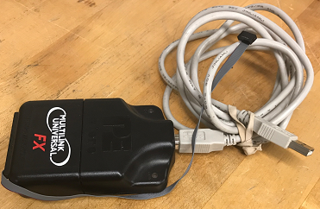

* USB to 1-Port RS-232 DB9 Serial Interface Adapter

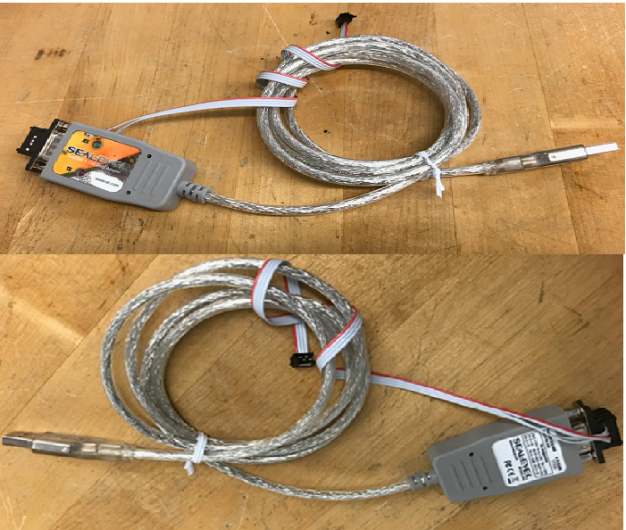

* + Download driver at <http://www.sealevel.com/support/software-seacom-windows/>
    - Scroll down to the Attachments section and click the section to download

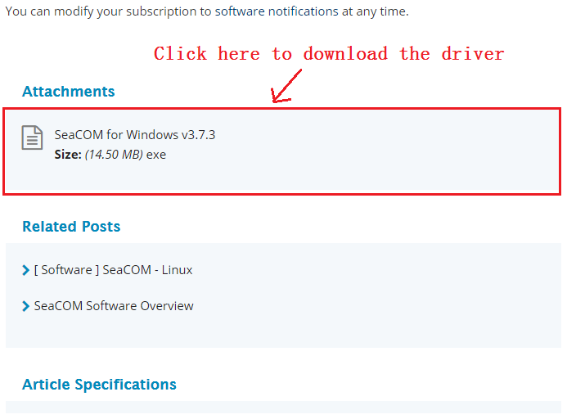

* 12V power source
* Display unit
* Require Operating System: Window 7 or later PC or Laptop
* RealTerm application, can be downloaded using this link <https://sourceforge.net/projects/realterm/>
* Kinetis Design Studio software Development tool, can be downloaded using this link <https://www.nxp.com/products/wireless-connectivity/zigbee/kinetis-design-studio-integrated-development-environment-ide:KDS_IDE>

**Programming the Display Unit**

This is a three parts process. The first part is to program the bootload project. The second part is to load the user application’s hex file via USB to RS232 converter cable. The third part deals with going into bootloader mode when the display unit is running in user mode. The Kinetis Design Studio (KDS) and Realterm will be used program two different project into the display unit. These two tools be configure at the same time. That is, the setting of Realterm can be done alongside with KDS setting. However, we will have to wait for the flashing of the bootload project to the display unit before we can load the user application to the display unit. That is, we want to put the display unit into bootloader mode first. Then we loading the user application second. Once we are done with the loading, the display unit will detect this and then jump to user mode. The *Programming the Bootloader Project* sections will focus on putting the display unit in bootload mode. The *Loading the User Application* sections will load the hex file of the user application to make the display unit run in user mode after the completion of loading.

The first section, *Programming the Bootloader Project,* will put the display unit in bootload mode. Once the display unit is running in the bootload mode, it will wait for the loading for the hex file for the user application. This loading of the user application is done using the Realterm application. The *Loading the User Application* section will details this. Upon successfully loading the user application, the display unit will detect this and jump to the user mode. Once the display unit is running in the user mode, it will be able to jump to the bootload mode using a key as shown in section *Go To Bootloader Mode from User Mode.*

*Programming the Bootloader Project*

The bootload project is programmed by flashing the hex file of the bootload project into the display unit. This is done using Kinetis Design Studio software development. It will require the use of a programmer as shown in Figure 2.

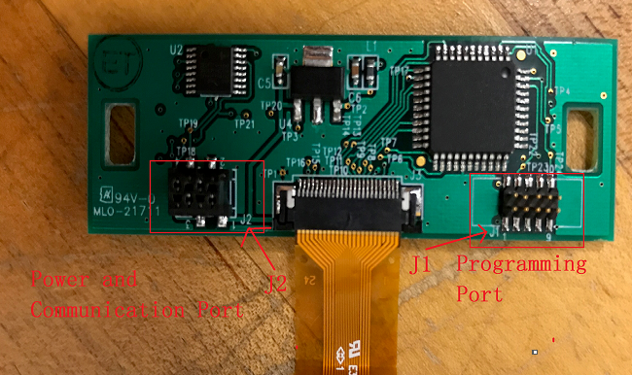

Figure 1. The Display Unit.

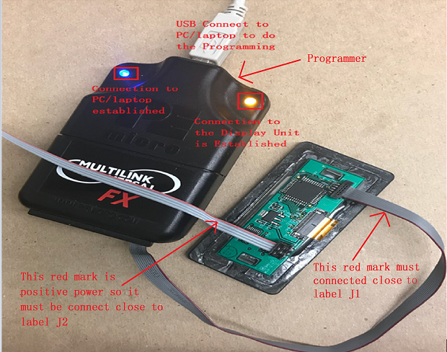

Figure 2. Complete Connection between Programmer and the Display Unit.

Once the connection shown in Figure 2 is established, the bootload project can be flashed into the display unit. We are using Kinetis Design Studio software development tool to do the flash as following:

1. Extract the “WorkStation.zip” file into a location that can be accessed easily. The following example extracted the “WorkStation.zip” into H:\UserAppAndBootloader location to arrive at the path shown in Figure 3.
2. Open the KDS. “A Select a workspace” window will pop up as shown in Figure 3. Select the correct path that contain the WorkStation folder in Workspace as highlighted. Then click “OK” to open the workspace.

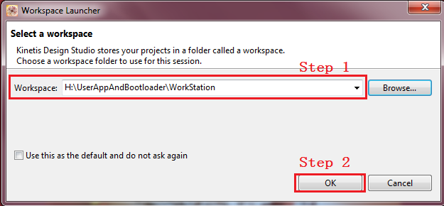

Figure 3. Locating the Correct Path to WorkStation folder.

1. Upon successfully open the KDS, a new screen will pop. Close the “Welcome to Kinetis Design Studio” window to get to the screen shown in Figure 4. Click on the “Flash” symbol shown in the red highlighted.

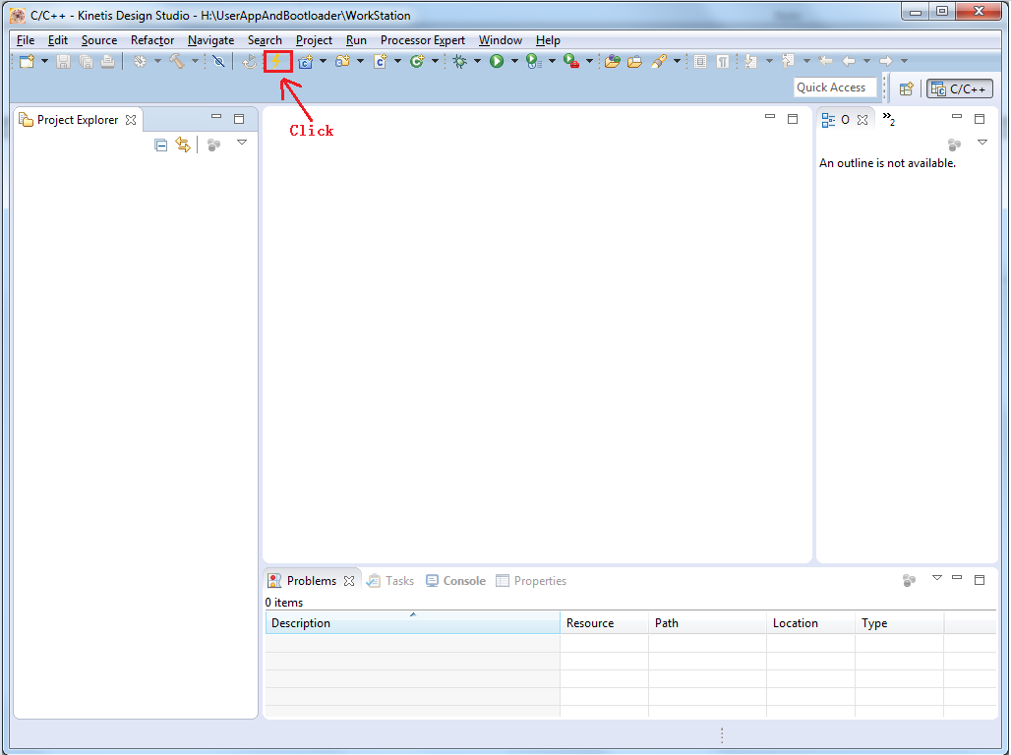

Figure 4. Locating the Flash Symbol on Kinetis Design Studio.

A new window open as shown in Figure 5. Expanded the “GDB PEMicro Interface Debugging” and then select the “New_configuration”. Go to the Main tab as highlighted below, use the highlighted “Browse…” button below the “C/C++ Application:” to browse the “Display_Bootloader.hex” file in the WorkStation folder.

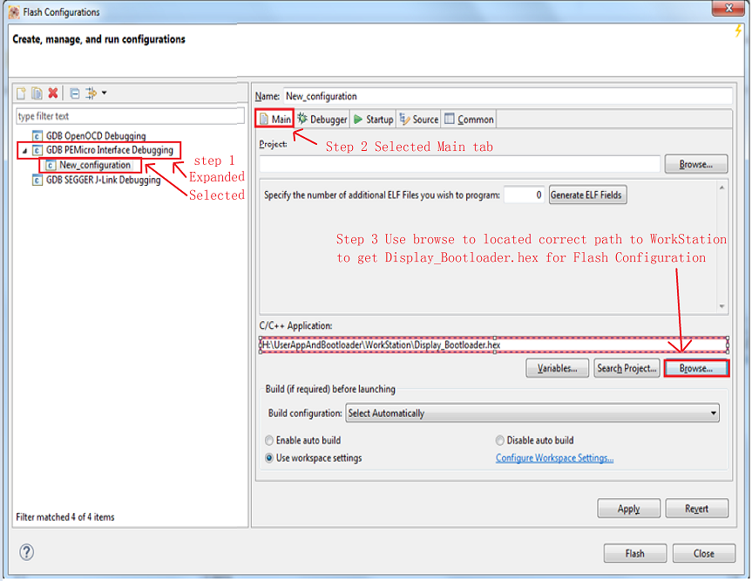

Figure 5. Main tab Setting for Flash Configuration.

Then go to the Debugger tab and change the setting as shown in Figure 6.

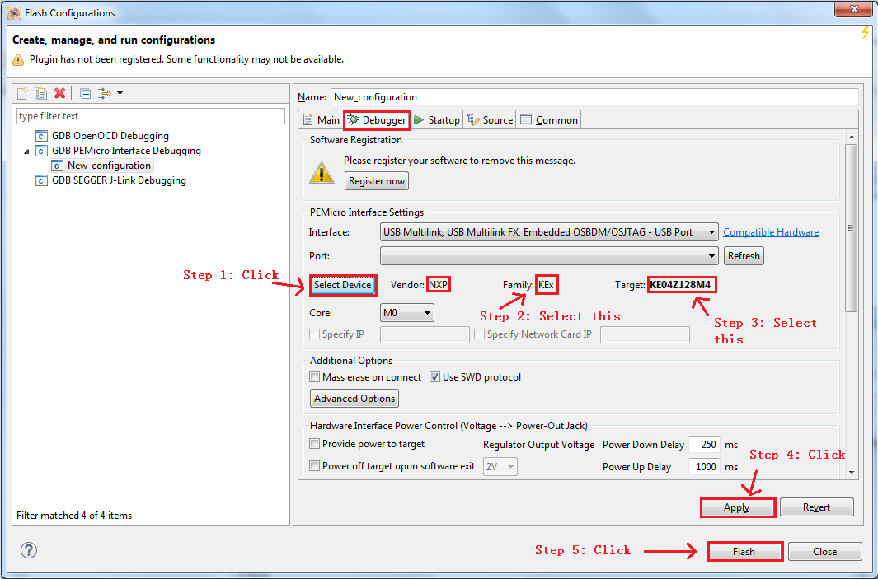

Figure 6. Debugger tab Setting for Flash Configuration.

Once step 5 is clicked, the bootloader project will be flashed into the display unit. The screen shown in Figure 7 will show up to indicate the progress of flashing. Once the it is done flashing, the display unit will contain just the program for bootload. The user application can be loaded into the display unit via direct connection to the Realterm application. Proceed to *Loading the User Application* to setup Realterm application to do the loading.

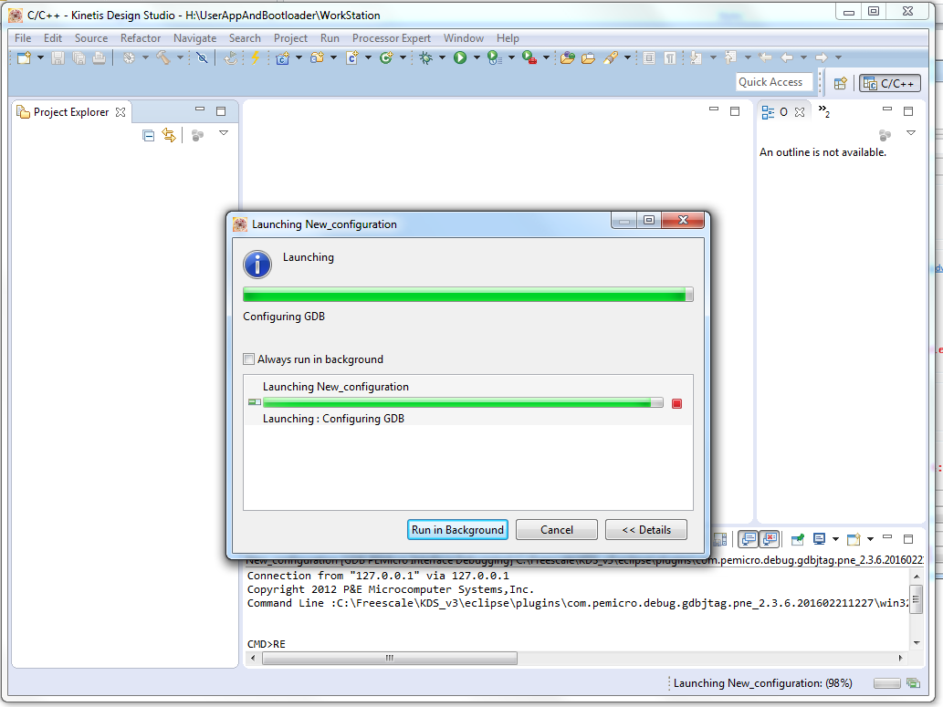

Figure 7. Flashing is Progressed.

*Loading the User Application*

The loading of the user application requires the connection between the PC/laptop that has Realterm application and the display unit. This connection is through USB to 1-Port RS-232 DB9 Serial Interface Adapter. Once the connection is established between the display unit and the PC/laptop that has the Realterm application, follow the following step to setup the Realterm to do the transfer of the hex file “Display_ProcessorUpdate.txt” to the display unit. Note that “Display_ProcessorUpdate.txt” contains the hex file of the user application. The display unit must have the bootloader project flashed into it already.

Refer to Figure 8a for a complete connection between the display unit and Realterm application to make the loading successful. Refer to Figure 8b to determine what each connection means. Refer to Figure 9 for power board connection. This power board is only there to provide power to the display unit in order to load the user application. The transmit and receiving pins of the display unit is connected to the receiving and transmit pins of the USB to 1-Port RS-232 DB9 Serial Interface Adapter.

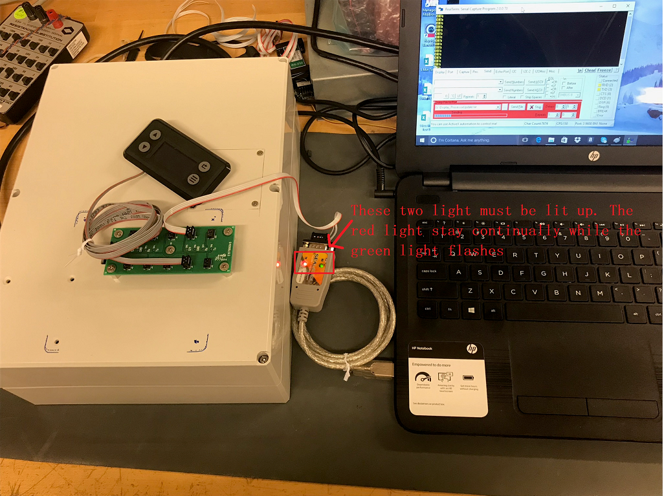

Figure 8a. Complete Connection to Load User Application

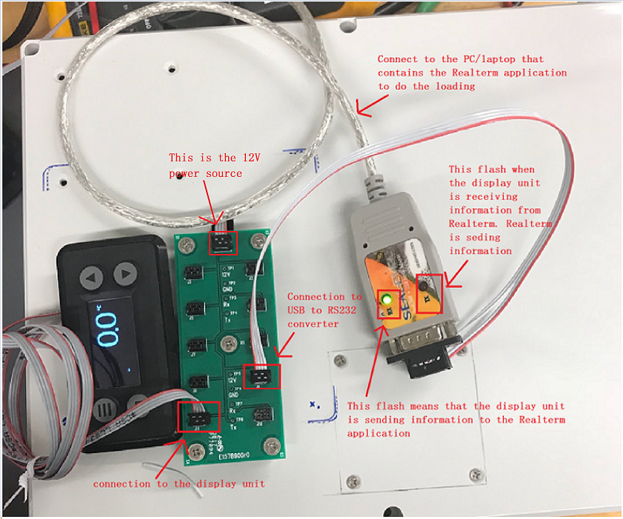

Figure 8b. Complete Connection Between the Display unit and Realterm.

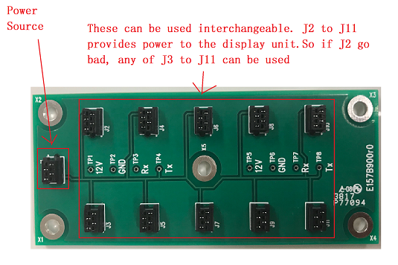

Figure 9. Power Board to the Display Unit.

1. Open the Realterm application and change the settings as shown in Figure 10.

In the “Display” tab, select “Ascii”.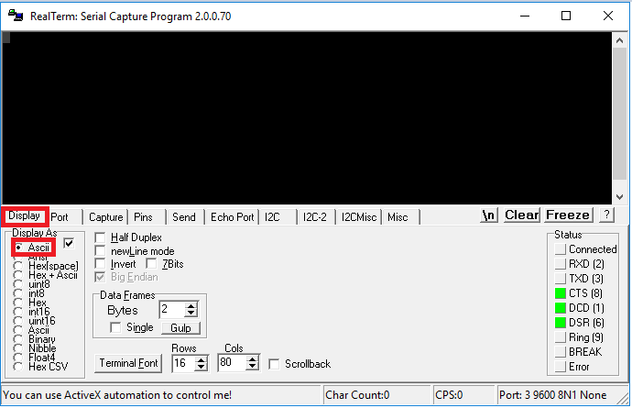

Figure 10. The Display tab’s Setting for Realterm.

On the “Port” tab as shown below on Figure 11, change the settings as highlighted. Note that the port number has to be correct in order to form the connection between the display unit and the RealTerm application. Check USB Serial Port to get the correct port number. In this case, it is port 3 for COM3.

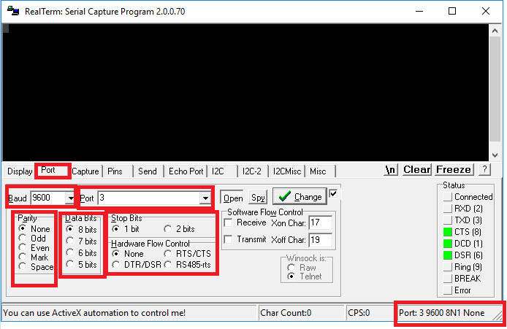

Figure 11. The Port tab’s Setting for Realterm.

On the “Send” tab shown in Figure 12, select the “Display_ProcessorUpdate.txt” resided in the WorkStation folder, must chose the correct path to get to “Display_ProcessorUpdate.txt”. Change the “Delays” as highlighted.

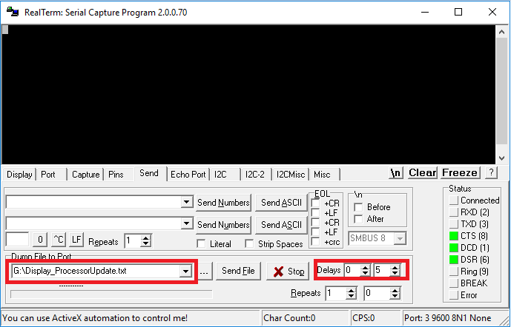

Figure 12. Setting of the Send tab for Realterm.

1. Once the RealTerm settings is completed, power cycle the display unit. That is, turn the power to the display unit off and on again to verify that the bootloader project is successfully flashed into the display unit. If successfully flashed, the word “READY” will be displayed on the RealTerm screen as shown in Figure 13. This “READY” signal is used to indicate that the display unit is ready to receive the hex file of the user application, “Display_ProcessorUpdate.” When “READY” is displayed, go to the Send tab highlighted shown in Figure 13 and click the “Send File” button to start load the hex file into the display unit.

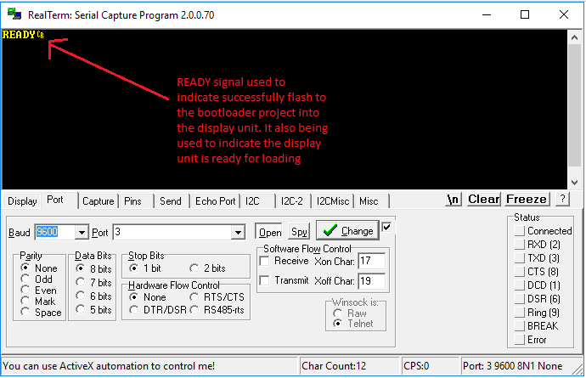

Figure 13. READY signal Initiates the Loading Process of User Application.

1. An “OK” shown in Figure 14 represents that each hex line is being received successfully.

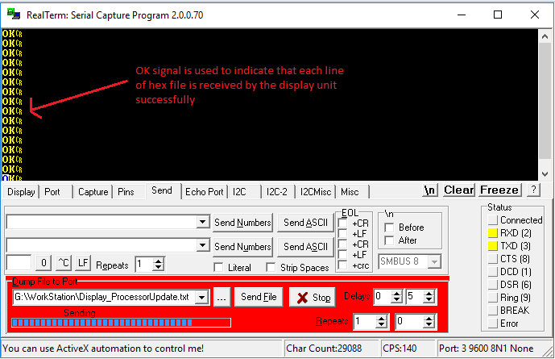

Figure 14. OK signal Indicates that each line of the hex file is received successfully by the display Unit.

1. Upon the completion of loading, the “USER” signal will be displayed to indicate that the loading is done and the display unit is about to go to user mode. The screen shown in Figure 15 means that the loading is successfully complete. Once this happen, no error occurs. If there are error, then proceed to step 5. An typical error screen look like Figure 16.

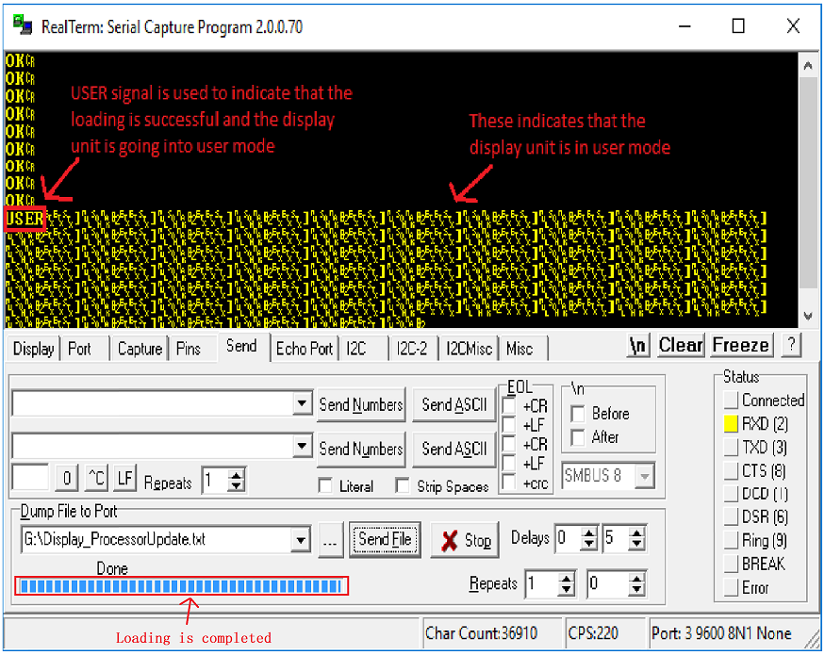

Figure 15. Successfully Loading the User Application and the Display Unit is running in User Mode.

1. If the loading is completed but the “USER” signal does not appeared on the Realterm screen, then there is a problem occur when loading. To solve this, simply cycle the power to the display unit. That is, turn the power off and on. Then, wait until the “READY” signal is displayed before sending the “Display_ProcessorUpdate.txt” file again. So, when the “READY” signal is displayed, go back to step 2 and repeated the process until successfully loading the hex file in step 4. This step also resolves any issue that occurs to prevent the loading to complete. In the case that cycle the power to the display unit does not show the “READY” signal, re-flash the display unit with the bootloader project as detail in the *Programming the Bootloader Project* section.

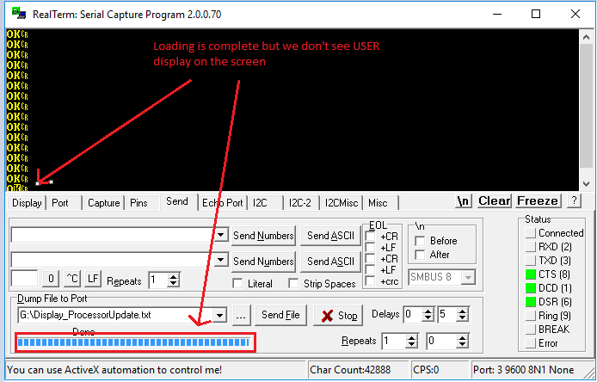

Figure 16. Unsuccessfully Loading the User Application.

Power cycle and wait for READY before repeating step 2 to step 4.

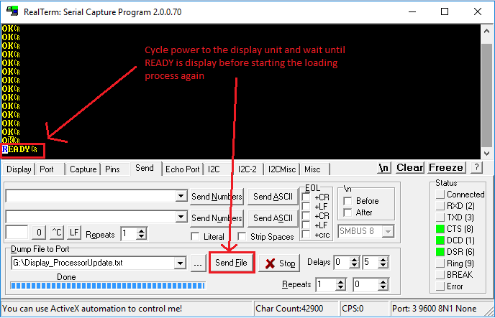

Figure 17. Power Cycle to See the READY Signal.

*Go To Bootloader Mode from User Mode*

This section deals with future update to an display unit that is either mounted to an enclosure or already programmed by the manufacturer. That means that display unit is running in user mode already. To be able to update the user application, the user must put the display unit into bootloader mode. To do this, the user must have access to a special key to tell the display unit to go to bootloader mode as shown in Figure 18. The special that is used is 0x03 0x06 0x02 0x5D 0x00 0x00. Note that this example is for when we have a direction connection established between the Realterm application and the display unit as shown in Figure 8a.

1. Sending the command to tell the display unit to go to bootloader mode as shown below in Figure 18. Note that the command may has to be sent multiple times until the display unit has the chance to check its receiving buffer to detect the command. When it detects the command, it will display text according to Figure 18b. So keep clicking the “Send Numbers” button until the display of Figure 18b shows up.

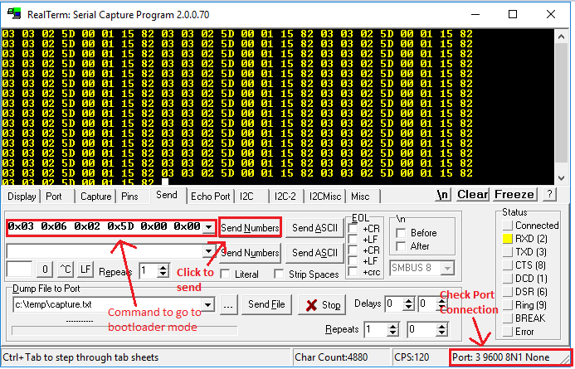

Figure 18a. Command the Display Unit into Bootloader Mode.

Once successfully send the bootloader command to the display unit. The display unit will detect the command and then display the text “Going into Bootloader Mode…” on the display screen before it send the READY signal to the Realterm screen as shown in Figure 19.

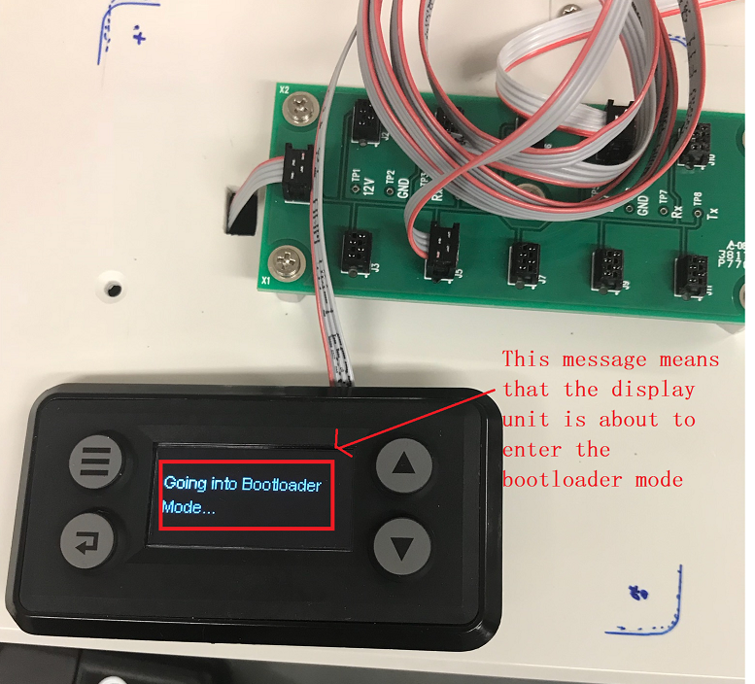

Figure 18b. The Display Unit Detect the Bootloader Command.

1. Upon successfully putting the display unit into bootloader mode, wait for the READY signal to be appeared in the Realterm application window as shown in Figure 19 before proceed to step 2 to 4 of *Loading the User Application* section to load the new updated user application.

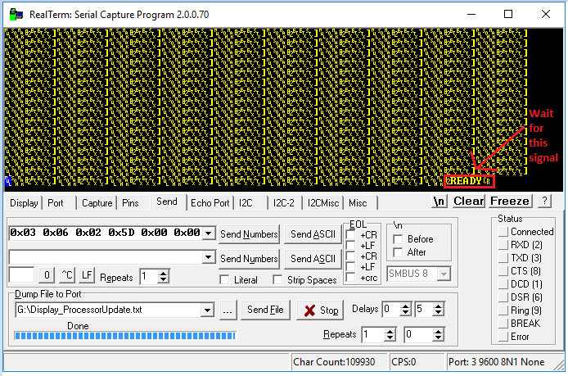

Figure 19. Wait for READY Signal after Sending the Bootloader Command to Display Unit.